Quiz - Week 9: Mixed Review

- A solid metal ball and a hollow plastic ball of the same external radius are released from rest in a large vacuum chamber. When each has fallen 1 m, they both have the same
  - inertia
  - speed
  - momentum
  - kinetic energy
  - change in potential energy

- A railroad car of mass m is moving at speed v when it collides with a second railroad car of mass M which is at rest. The two cars lock together instantaneously and move along the track. What is the speed of the cars immediately after the collision?
  - v/2
  - mv/M
  - Mv/m
  - (m + M )v/m
  - mv/(m+M)

- Quantities that are conserved in all nuclear reactions include which of the following?
I. Electric charge
II. Number of nuclei
III. Number of protons
  - I only
  - II only
  - I and III only
  - II and III only
  - I, II, and III

- Two parallel conducting plates are connected to a constant voltage source. The magnitude of the electric field between the plates is 2,000 N/C. If the voltage is doubled and the distance between the plates is reduced to 1/5 the original distance, the magnitude of the new electric field is
  - 800 N/C
  - 1,600 N/C
  - 2,400 N/C
  - 5,000 N/C
  - 20,000 N/C

- In a certain process, 400 J of heat is added to a system and the system simultaneously does 100 J of work. The change in internal energy of the system is
  - 500 J
  - 400 J
  - 300 J
  - -100 J
  - -300 J

- A concave mirror with a radius of curvature of 1.0 m is used to collect light from a distant star. The distance between the mirror and the image of the star is most nearly
  - 0.25 m
  - 0.50 m
  - 0.75 m
  - 1.0 m
  - 2.0 m
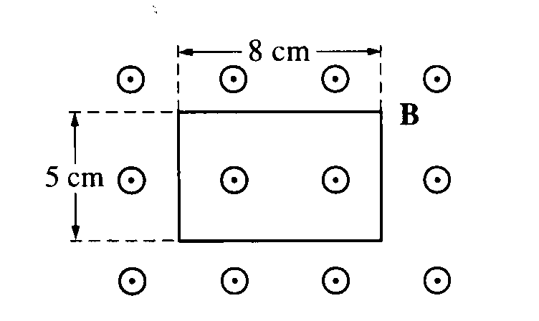
- A rectangular wire loop is at rest in a uniform magnetic field B of magnitude 2 T that is directed out of the page. The loop measures 5 cm by 8 cm, and the plane of the loop is perpendicular to the field, as shown above. The total magnetic flux through the loop is
  - zero
  - 2 x 10⁻³ Tm²
  - 8 x 10⁻³ Tm²
  - 2 x 10⁻¹ Tm²
  - 8 x 10⁻¹ Tm²
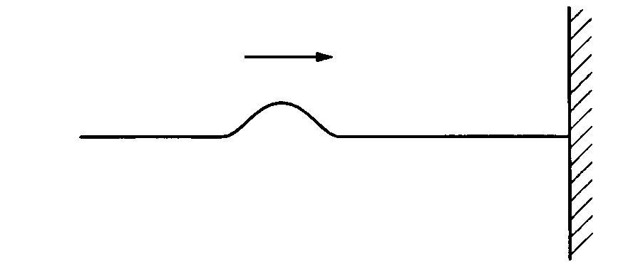
- One end of a horizontal string is fixed to a wall. A transverse wave pulse is generated at the other end, moves toward the wall as shown above. and is reflected at the wall. Properties of the reflected pulse include which of the following?
I. It has a greater speed than that of the incident pulse.
II. It has a greater amplitude than that of the incident pulse.
III. It is on the opposite side of the string from the incident pulse.
  - I only
  - III only
  - I and II only
  - II and III only
  - I, II, and III

- If photons of light of frequency f have momentum p, photons of light of frequency 2f will have a momentum of
  - 2p

  - p

  - p/2
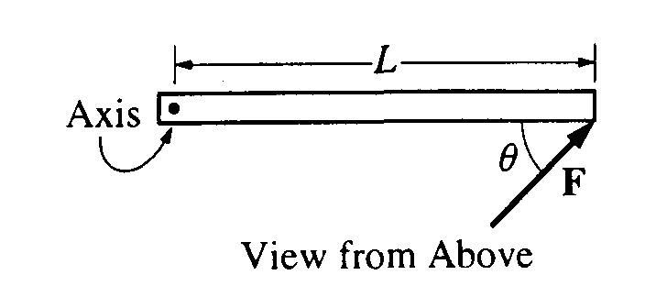

- A rod on a horizontal tabletop is pivoted at one end and is free to rotate without friction about a vertical axis, as shown above. A force F is applied at the other end, at an angle θ to the rod. If F were to be applied perpendicular to the rod, at what distance from the axis should it be applied in order to produce the same torque?
  - L sin θ
  - L cos θ
  - L
  - L tan θ
  - L

